Assignment 1
Table 1: SalesPeople

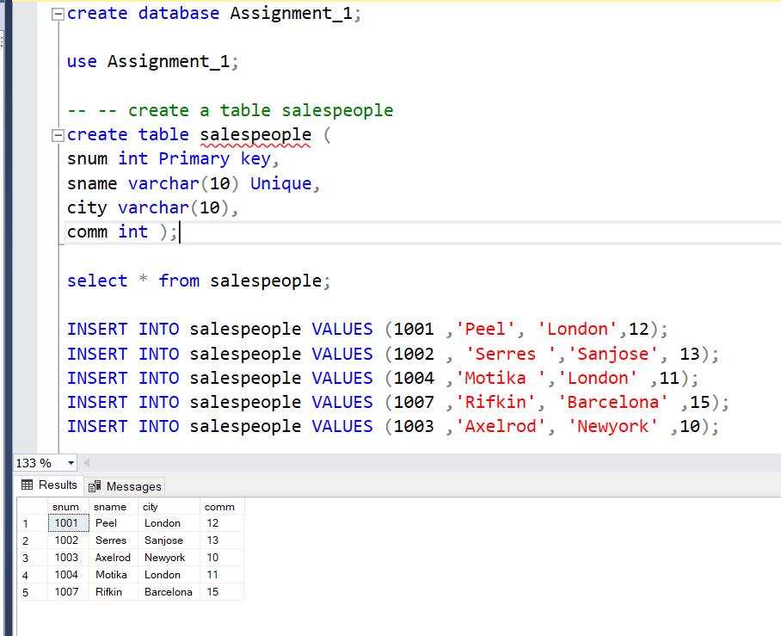

Table 2: Customers

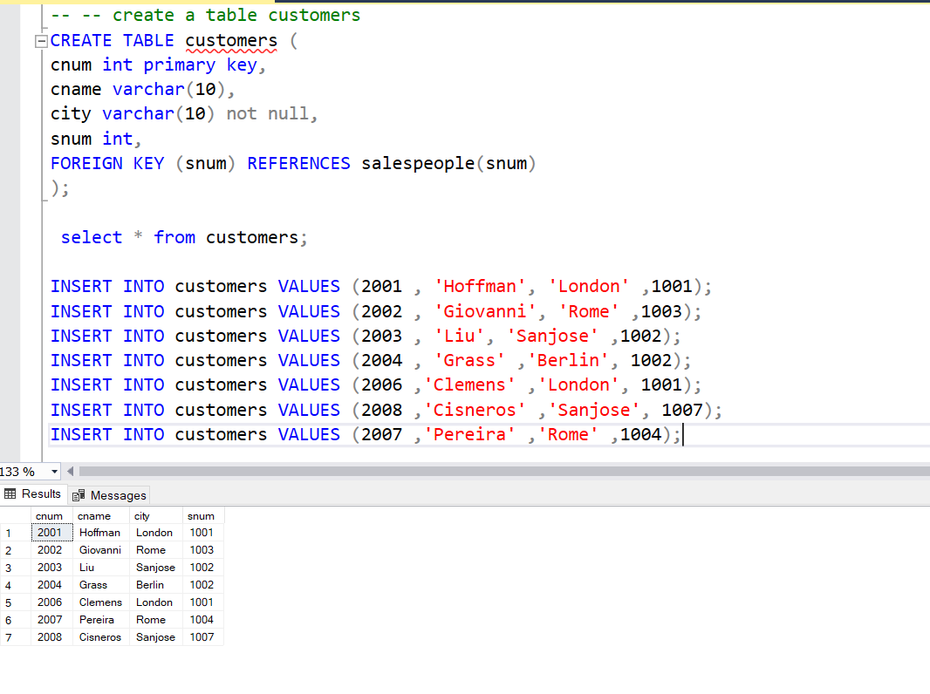

Table 3: Orders

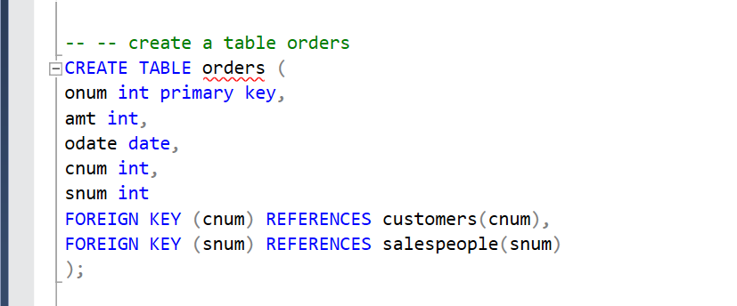

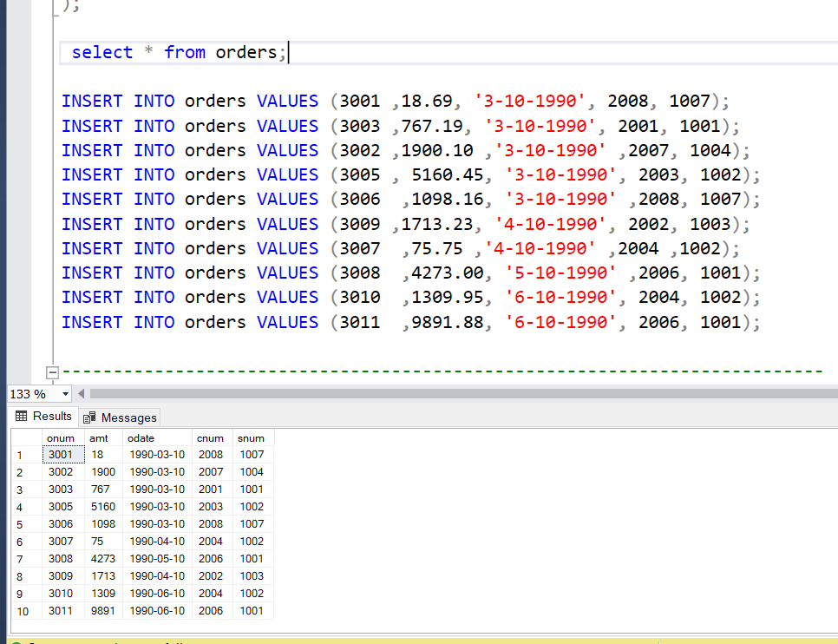

--On the basis of above tables perform given below questions

---1. Count the number of Salesperson whose name begin with ‘a’/’A’.

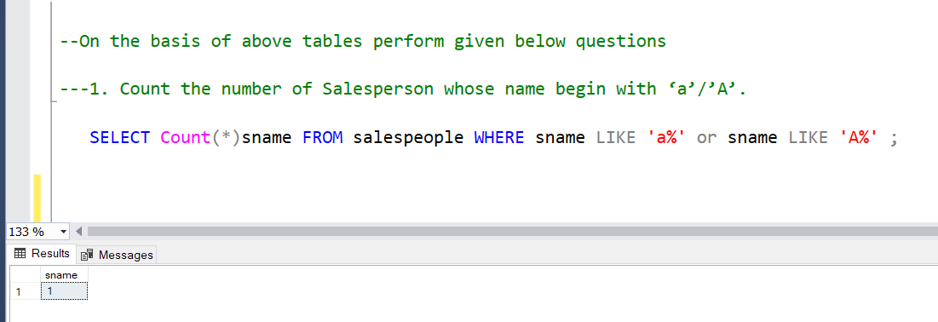

----2. Display all the Salesperson whose all orders worth is more than Rs. 2000.

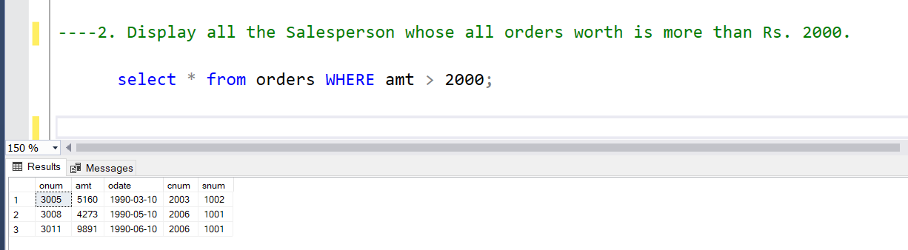

----3.Count the number of Salesperson belonging to Newyork.

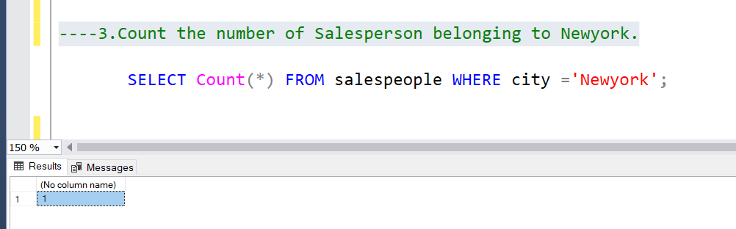

---4.Display the number of Salespeople belonging to London and belonging to Paris.

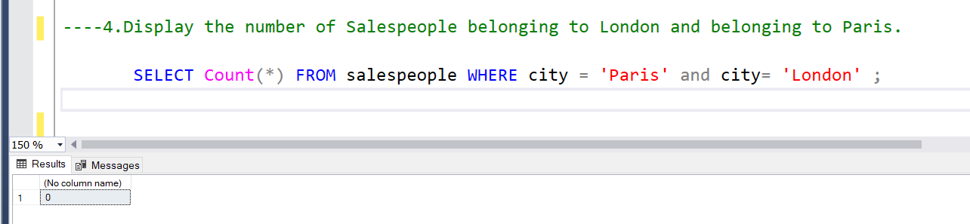

----5.Display the number of orders taken by each Salesperson and their date of orders.

